**Project Write-up**

DESCRIPTION

**Project objective:**

As a developer, fix the bugs in the application using the appropriate algorithmic techniques.

**Background of the problem statement:**

You have been assigned a few tasks during the sprint planning. Solving the bugs raised by the testing team is one among them. You are given the boilerplate code and are asked to complete it by fixing the bugs.

**Fix Bugs of the Application.**

package Fix_Bugs_Of_The_Application;

import java.util.ArrayList;

import java.util.Arrays;

import java.util.Collections;

import java.util.Scanner;

public class BugFix {

public static void main(String[] args) {

System.out.println("\t MENU \n");

System.out.println("************************************");

optionsSelection();

}

private static void optionsSelection() {

String[] arr = {"1. I wish to review my expenditure",

"2. I wish to add my expenditure",

"3. I wish to delete my expenditure",

"4. I wish to sort the expenditures",

"5. I wish to search for a particular expenditure",

"6. Close the application"

};

int[] arr1 = {1,2,3,4,5,6};

int slen = arr1.length;

for(int i=0; i<slen;i++){

System.out.println(arr[i]);

// display the all the Strings mentioned in the String array

}

ArrayList<Integer> arrlist = new ArrayList<Integer>();

ArrayList<Integer> expenses = new ArrayList<Integer>();

expenses.add(1000);

expenses.add(2300);

expenses.add(45000);

expenses.add(32000);

expenses.add(110);

expenses.addAll(arrlist);

System.out.println("\nEnter your choice:\t");

Scanner sc = new Scanner(System.in);

int options = sc.nextInt();

for(int j=1;j<=slen;j++){

if(options==j){

switch (options){

case 1:

System.out.println("Your saved expenses are listed below: \n");

System.out.println(expenses+"\n");

optionsSelection();

break;

case 2:

System.out.println("Enter the value to add your Expense: \n");

int value = sc.nextInt();

expenses.add(value);

System.out.println("Your value is updated\n");

expenses.addAll(arrlist);

System.out.println(expenses+"\n");

optionsSelection();

break;

case 3:

System.out.println("You are about the delete all your expenses! \nConfirm again by selecting the same option...\n");

int con_choice = sc.nextInt();

if(con_choice==options){

expenses.clear();

System.out.println(expenses+"\n");

System.out.println("All your expenses are erased!\n");

} else {

System.out.println("Oops... try again!");

}

optionsSelection();

break;

case 4:

sortExpenses(expenses);

optionsSelection();

break;

case 5:

searchExpenses(expenses);

optionsSelection();

break;

case 6:

closeApp();

break;

default:

System.out.println("You have made an invalid choice!");

break;

}

}

}

}

private static void closeApp() {

System.out.println("Closing your application... \nThank you!");

}

private static void searchExpenses(ArrayList<Integer> arrayList) {

int leng = arrayList.size();

System.out.println("Enter the expense you need to search:\t");

//

Scanner sc = new Scanner(System.in);

int input = sc.nextInt();

//Linear Search

for(int i=0;i<leng;i++) {

if(arrayList.get(i)==input) {

System.out.println("Found the expense " + input + " at " + i + " position");

}

}

}

private static void sortExpenses(ArrayList<Integer> arrayList) {

int arrlength = arrayList.size();

//Complete the method. The expenses should be sorted in ascending order.

Collections.sort(arrayList);

System.out.println("Sorted expenses: ");

for(Integer i: arrayList) {

System.out.print(i + " ");

}

System.out.println("\n");

}

}

**Output:**

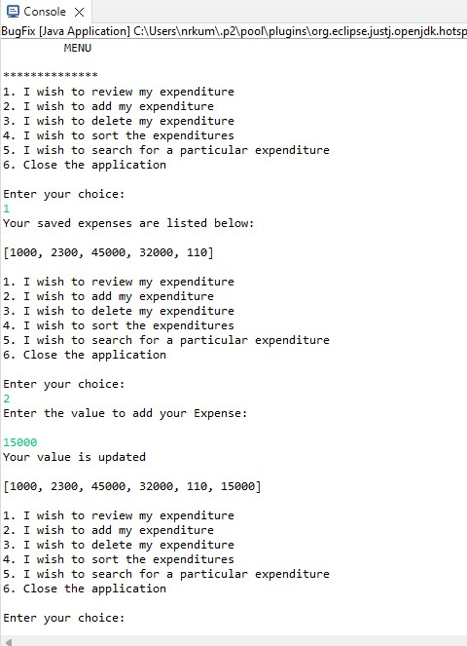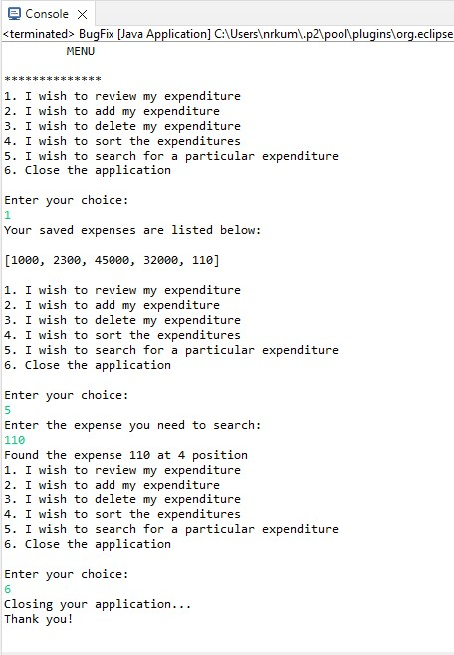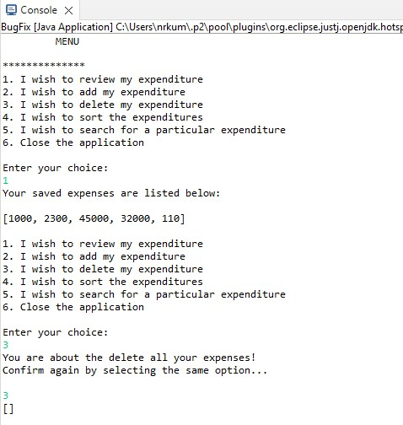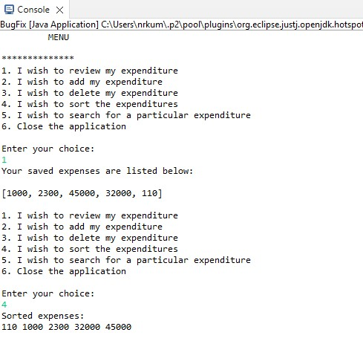

Pushing the code to your GitHub repositories

* Open your command prompt and navigate to the folder where you have created your files.

**cd <folder path>**

* Initialize your repository using the following command:

**git init**

* Add all the files to your git repository using the following command:

**git add .**

* Commit the changes using the following command:

**git commit . -m “Changes have been committed.”**

* Push the files to the folder you initially created using the following command:

**git push -u origin master**